**FULL STACK APPLICATION –ACCOUNT MANAGEMENT (SYSTEM)**

# 

Account Details:

**customer name and account number**. Basic: It includes the basic information about the account, like customer ID, account type, mode of operation, status, etc. Balance and Limits: It includes information like available balance, amount hold, net balance, unclear funds, overdraft limits, etc.

**check account details :**

Navigate to your bank's website on a computer or open up their mobile app on your phone or tablet. Sign in and click on the tab to view a summary of your account. Usually, the account number will be listed on this page. If it's not, search through the website or use the “Help” function to find it.

**TECHOLOGIES USED**

ANGULAR CLI

CLI

SPRING

BOOT

BOOT

JPA

FULL STACK

APPLICATION

NODE JS

MYSQL

HIBERNATE

**ARCHITECTURE OF ANGULAR**

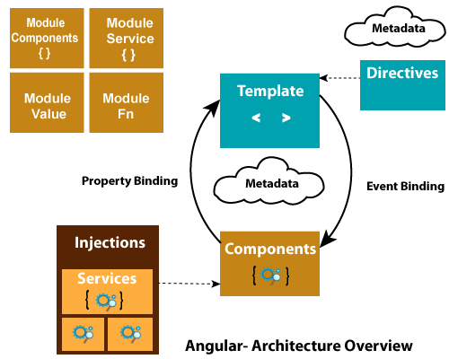

Components **:**

Every Angular project has at least one component, the root component and root component connects the component hierarchy with a page document object model (DOM).

**ARCHITECHTURE OF STS AND HIBERNATE**

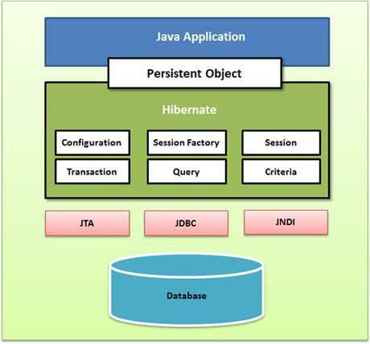

**HIBERNATE:**

Hibernate has a layered architecture which helps the user to operate without having to know the underlying APIs. Hibernate makes use of the database and configuration data to provide persistence services (and persistent objects) to the application.

**APPLICATION OF MYSQL**

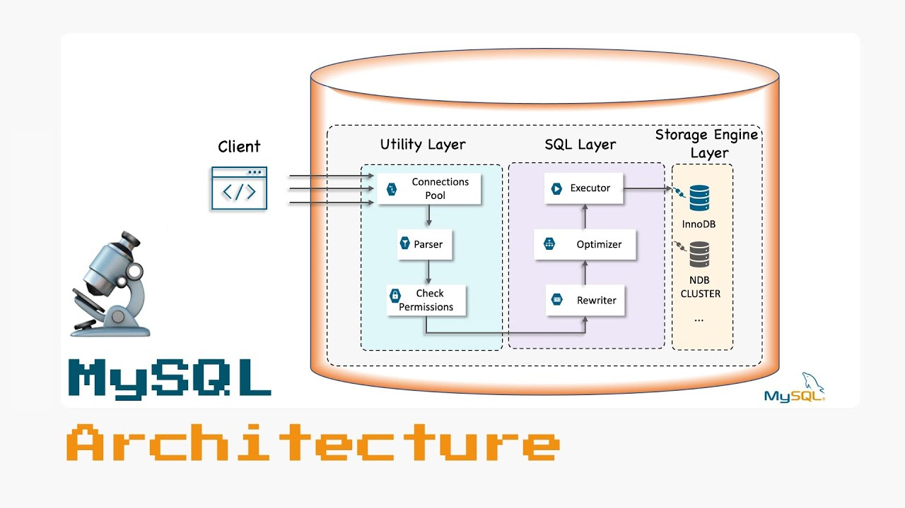

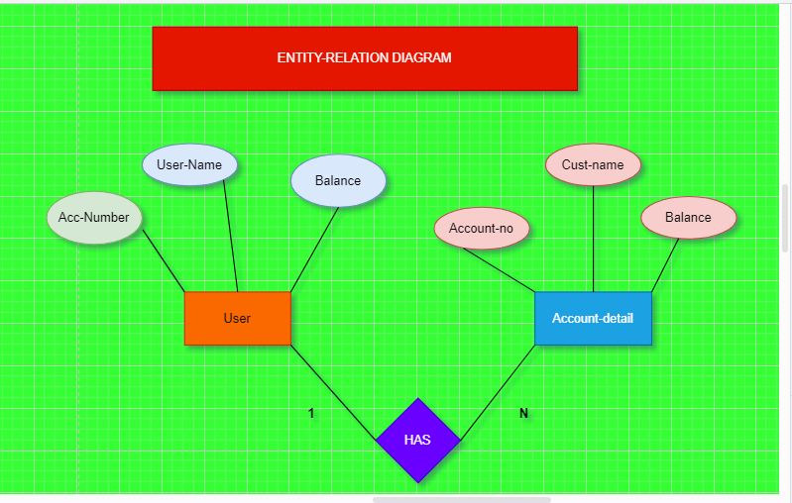

**MYSQL :**

MYSQL is a relational database with **a layered kind of architecture**. The layers of the architecture include a server resource end at the middle, the storage engine at the bottom, and the client-end or query execution end at the top. It's a three-layered architecture database system.

**ARCHITECTURE OF ANGULAR SPRING AND MYSQL**

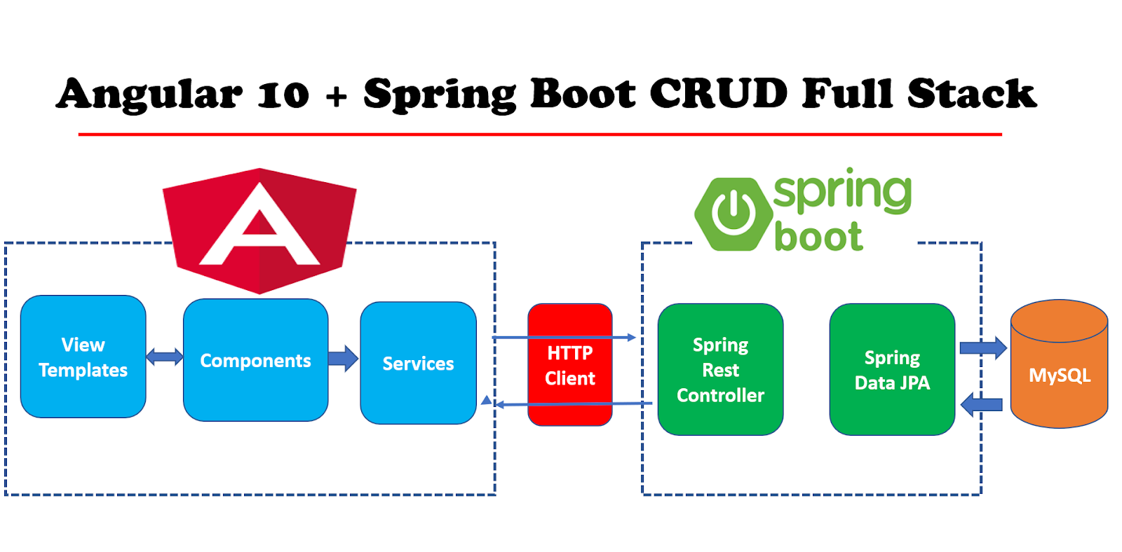**Implementation**

1. Configure Spring Datasource, JPA, Hibernate.
2. Define Data Model.
3. Create Repository Interface.
4. Create Spring Rest APIs Controller.
5. Create & Setup Spring Boot project.
6. Run the Spring Boot Server.
7. Setup Angular 11 Project.

**ARCHITECTURE OF MY PROJECT**

**CRUD OPERATION**

**HTTPS**

**MYSQL**

**SPRING BOOT**

**NODE JS**

**ANGULAR**

***BACKEND***

***FRONTEND***

**UPDATE**

**RECORD**

**INSER**

**RECORD**

**DELETE**

**RECORD**

**VIEW**

**RECORD**

**INSERT UPDATE AND VIEW RECORD**

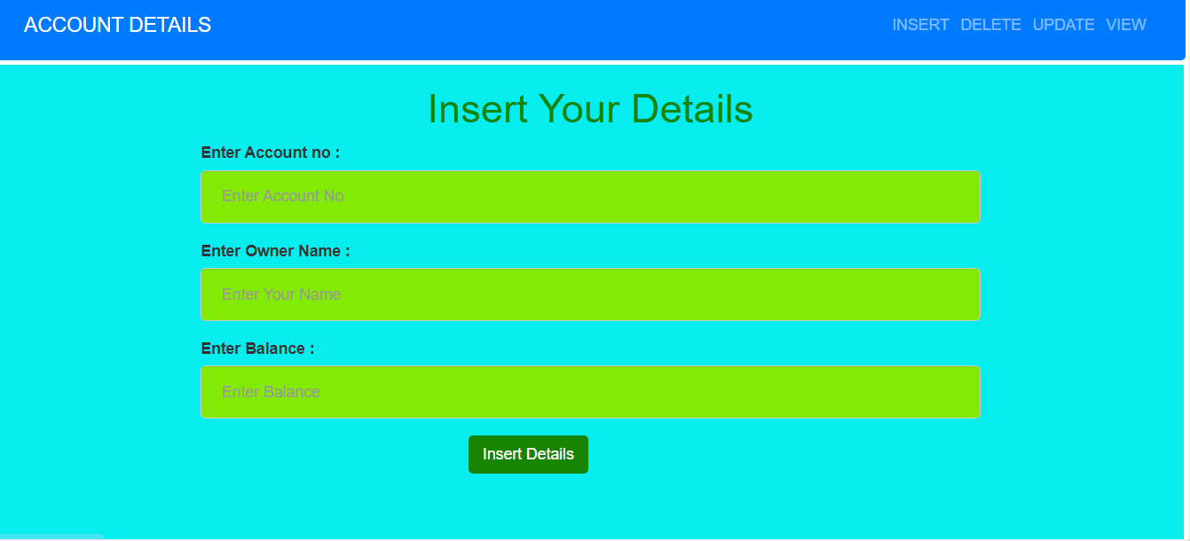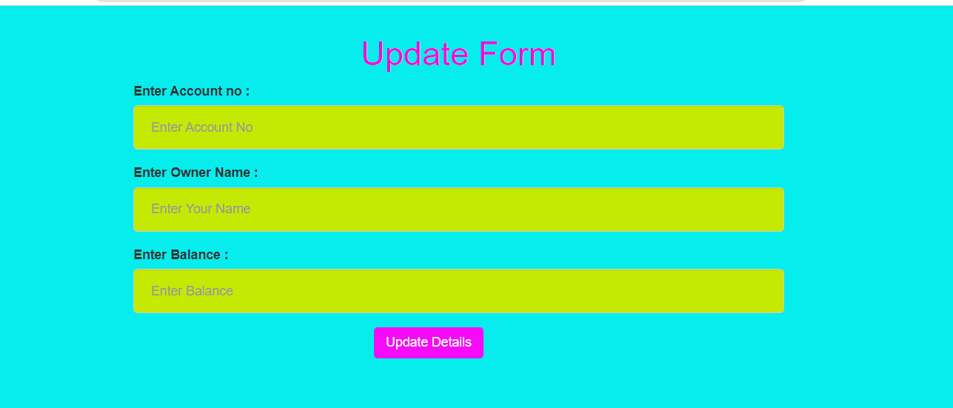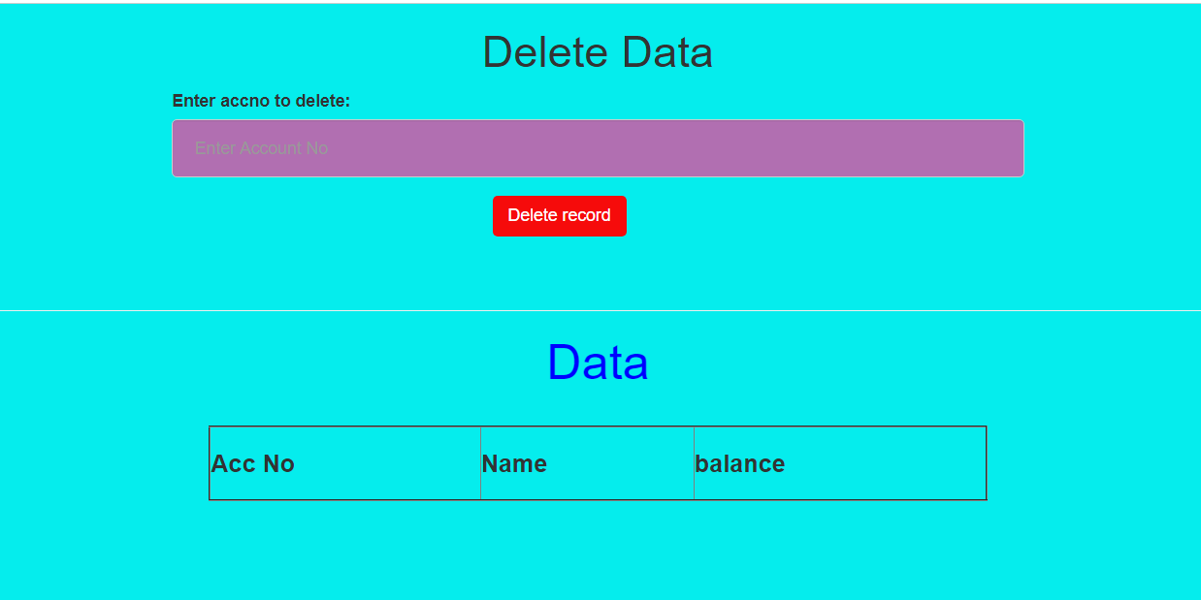

**Angular code**

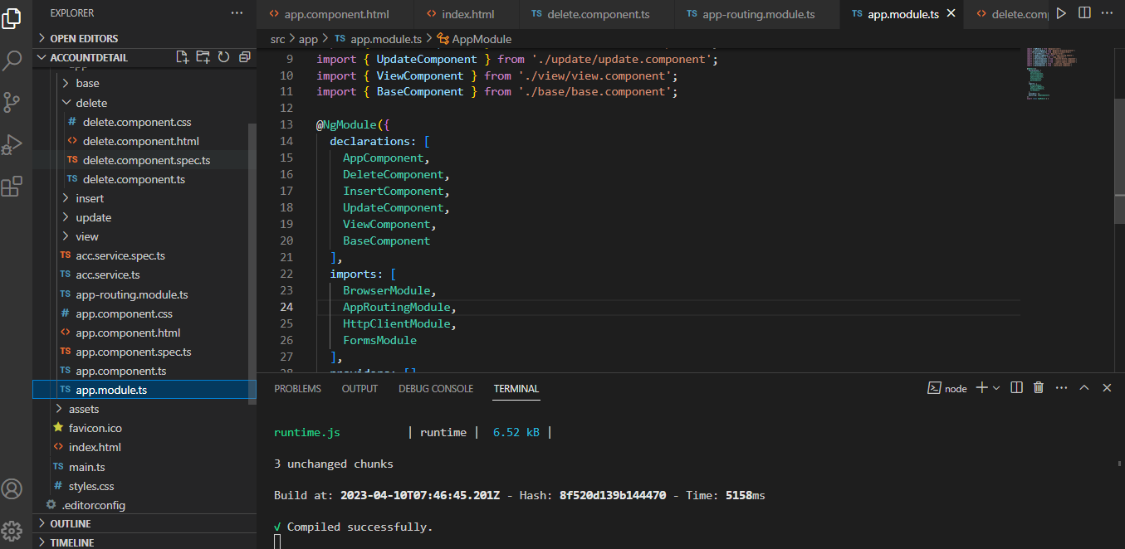

**STS CODE**

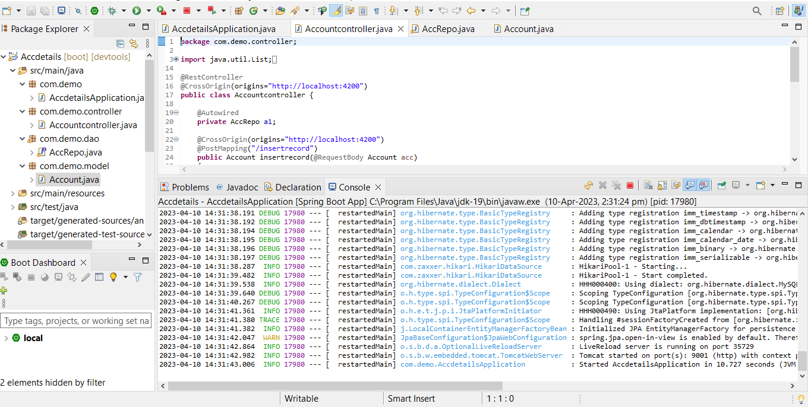

**MYSQL CODE**

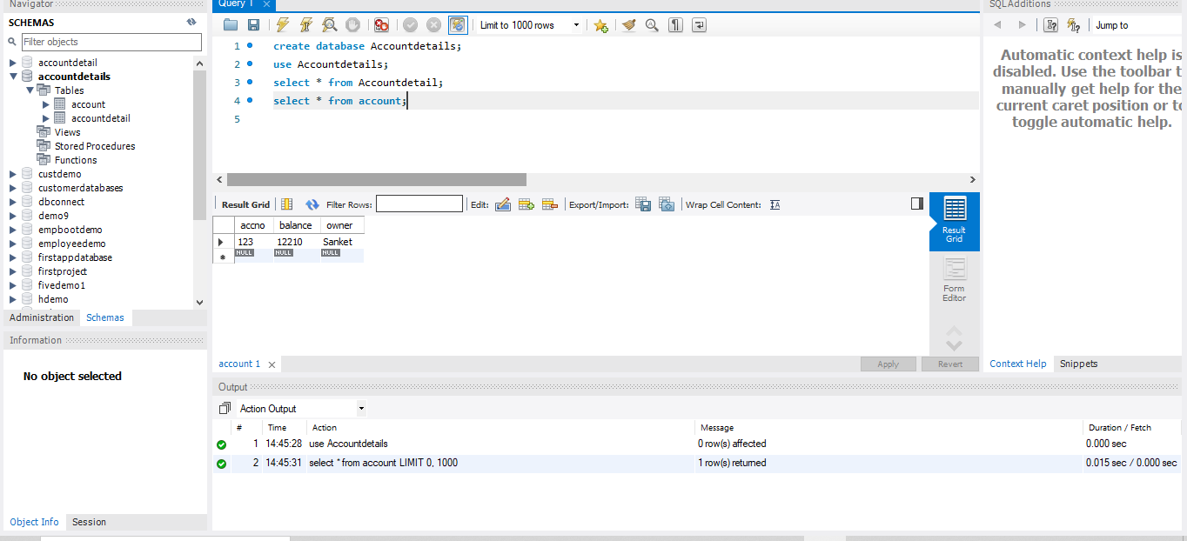

**FUTURE SCOPE**

The scope of accounting includes all financial transactions and activities of a company. It includes recording, classifying, and summarizing financial information to provide accurate and timely reports. Accounting tracks the performance of a business and helps make crucial decisions about its future.



**GIT HUB LINK**